For submission in: ?

**Birds of a feather flock together: Light pollution’s effects differ by social context.**

Cassandra K. Hui1*, Yong Zhang2, Jenny Q. Ouyang1

1 Department of Biology, University of Nevada, Reno

1664 N Virginia St, Reno, NV 89557

2 Jiangsu Key Laboratory of Neuropsychiatric Diseases and Cambridge-Suda Genomic Resource Center, Suzhou Medical College, Soochow University, Suzhou 215123, China

*Corresponding author: chui@unr.edu

**Abstract**

Artificial light at night (ALAN), a growing pervasive pollutant, disrupts physiological and behavioral rhythms across organisms. Social interactions play a significant role in shaping individual and group biological rhythms, but they are often overlooked in the context of environmental stressors, such as ALAN. We explore how dim ALAN affects zebra finches (*Taeniopygia guttata*) in social and isolated environments, examining behavioral, physiological, and molecular rhythms. We found that social birds under ALAN had an earlier activity onset and greater disruption in hypothalamic and liver circadian gene expression than control or isolated counterparts under ALAN. Additionally, we found that activity onset correlated negatively with hypothalamic *bmal1* and *cry1* expression and positively with *per2* expression in birds exposed to ALAN. Within ALAN-exposed birds, there was a larger disassociation between central and peripheral clock gene expression for social birds than in isolated birds. However, rhythmic melatonin concentrations did not differ among treatment groups. We show that social interactions may exacerbate the effects of ALAN, which highlights the impact of social interactions on circadian regulation at a molecular level and a critical need to consider social contexts in biological studies.

**Introduction**

The advent of artificial light at night (ALAN) presents a formidable challenge to daily life, potentially disrupting the circadian system's delicate balance in molecular, physiological, and behavioral rhythms, thereby impacting overall health (*1*). Organisms across taxa synchronize biological rhythms with external cues, such as light and temperature, to maintain alignment with the day-night cycle. At the heart of these rhythms is the circadian clock, governed by a feedback loop of oscillating pacemaker genes. Clock (*Clk*) and Brain and muscle Arnt-like protein-1 (*bmal1*) genes promote Period (*per*) and Cryptochrome (*cry*) expression, which in turn repress their own activity (*2*). This system is entrained to environmental cues, primarily by the degradation of the PER/CRY protein complex in light (*2*). The main clock, in the suprachiasmatic nucleus (SCN) nestled in the hypothalamus, coordinates peripheral clocks in other tissues, such as the liver, which can also entrain downstream physiology and behaviors, like hormone secretion and activity periods (*3*).

Melatonin, produced by the pineal gland during the night, serves as a critical signal for sleep readiness and regulates various biological functions as it aligns with the night-day cycle (*4*). Its production, tightly controlled by the circadian clock, forms a vital link between the external environment's light-dark cycle and the organism's internal biological processes. However, the effects of ALAN on melatonin production are varied in the literature depending on the light intensity and species (*5-8*).

Despite the established disruptive effects of ALAN on a wide variety of circadian regulation from neuronal activity to behavior (*6, 9, 10*), much of the existing research has concentrated on isolated animal models or housing conditions have largely been ignored (*6, 7*). Yet social interactions play a pivotal role in shaping circadian regulation and behavioral rhythms, suggesting a complex interplay between social environments and the internal biological clock (*11-13*). In social settings, organisms often synchronize their activities and physiological processes for various benefits, including enhanced reproductive success and survival (*14-16*). In flies, groups align activity rhythms and even shorten their natural rhythm if a short-period mutant is introduced (*17*). In mammals, the degus synchronize their activity patterns socially only if olfactory processing is present, indicating an underlying molecular mechanism (*18*). Additionally, a recent study showed that paired birds can restore rhythmic activity in an arrhythmic environment of constant light (*19*). Therefore, we need systematic social studies to fully understand ALAN’s impact. Our study aims to investigate whether social conditions alter the effects of ALAN. We predict based on the limited studies available investigating social circadian rhythms, that social interactions might mitigate the effects of this pervasive sensory pollutant.

We exposed zebra finches (*Taeniopygia guttata*), a social diurnal model organism, to ALAN in both isolated and social conditions. We compared activity levels, circadian gene expression in the hypothalamus and liver, and melatonin of control and ALAN-exposed birds housed in isolated or social settings. We chose these metrics for a comprehensive analysis of clock changes responding to ALAN, aiming to explore core and peripheral mechanistic clock changes and their interactions. If social conditions provide circadian rescue, we predicted that circadian disruption, *i.e*., misalignment of gene-expression, physiology, and behavior with light-dark conditions, would be less in ALAN-exposed birds housed socially than in isolated conditions. Alternatively, ALAN could be a strong enough *zeitgeber* or stressor that the social context has no effect. In this case, ALAN exposure would elicit similar responses regardless of social condition. Lastly, social context could amplify ALAN’s effects, prorogating them throughout the group, thereby leading to enhanced circadian disruption compared to isolated ALAN-exposed birds.

**Methods**

*Experimental Design*

We housed 99 zebra finches individually (n=53; 47 x 31 x 36cm cages) or grouped indoors (n=46, 47 x 93 x 36 cm cages) and entrained them to 12 hours light and 12 hours dark (12L:12D) for three weeks. Grouped (social) cages held 3 males and 3 females. For daylight, we used 1.4-Watt 5000 K light emitting diode (LED) rated at 95 Lumens lights at 9:00 (zeitgeber time (ZT) 0) and lights off at 21:00 (ZT 12). Birds were provided with food and water *ad libitum*. Each cage contained a mechanized perch that relayed hop activity to MATLAB every minute. Cages had individual light-occlusion shades and constant white noise in the background to limit visual and acoustic cues across cages. We also video-recorded cages containing groups of birds every half hour for two minutes (*20*).

We randomly assigned birds to one of four conditions: social ALAN (n=24, 12L:12L dim), isolated ALAN (n=26, 12L:12L dim), social control (n=22, 12L:12D), and isolated control (n=27, 12L:12D). ALAN was standardized to ~5 lux ± 0.01 from a 20 x 1.5 cm 5000 K broad spectrum LED strip using an Extech Easyview Digital Light Meter (model EA13) and lux was calculated using a mean measurement at perch height and two opposing base corners. For a full-spectrum description of the lights, please see (*7*). As determined by One-Way ANOVA, groups did not differ in initial mass (p= 0.25). After a 3-week entertainment period, we exposed individuals to ALAN or continued control conditions for 10 days. We then sacrificed the birds at four time points: ZT 1, ZT 7, ZT 13, and ZT19 (ZT 0 = lights on).

To acquire individual-based melatonin data, we repeated the experiment with new birds (social ALAN: n=12, isolated ALAN: n=7, social control: n=12, and isolated control: n=9), collecting within-individual blood samples at four different times (ZT 1, ZT 7, ZT 13, and ZT 19). We collected blood samples after nine days of ALAN exposure at 4 different time points over 10 days (no more than 1% of their body mass per 48 hours).

*Real-Time qPCR*

We used real-time PCR quantification with SYBR-Green to detect circadian gene expression in the hypothalamus and liver (*7*). We homogenized the tissues and analyzed in triplicate for technical repeats. We isolated total tissue RNA using Trizol (Life Technologies, Carlsbad, California) and quantified it using Nanodrop 1000 (Thermo Scientific). Reverse transcription was done from 3 mg of total RNA through Versco cDNA synthesis kit. We designed the primers using Primer 3 based on Zebra Finch *cry1*, *bmal1*, *per2*, and *per3* genes (Table S1). Amplicon abundance was calculated using the 2-∆∆CT method.

*Melatonin concentrations*

We measured plasma melatonin concentrations using an enzyme-linked immunoassay kit (Aviva Systems Biology OKEH02566) on 96-well plates according to manufacturer procedures and validated for zebra finches (*7*). When available, 25 mL of plasma was diluted (2X) and run in duplicate. The plate was read at 450 nm using a standard microplate reader (BioTek Synergy HTX multi-mode reader) and BioteGen5 data analysis software (BioTek Instruments, Inc, Winooski, Vermont). The interplate coefficient of variation (CV) was 6.4% and the intraplate CV was 5.3%. To increase accuracy, we normalized melatonin levels within each experimental round, ran 6 months apart.

*Statistical Analyses*

We analyzed all data using R version 4.1.2 (R Development Core Team, 2019). A Welch two-sample t-test was used to test for differences in nocturnal activity between control and ALAN for individually caged and social birds. We used the program Chronoshop 1.1 (freely available; see supplementary) to calculate activity onset (the first time point at which activity is higher than the average) and activity offset (the final time point at which activity is higher than the average) for each day relative to lights on and off. An ANOVA with Tukey’s post hoc comparison was used to determine differences in activity on- and offset. Cosinor (version 1.2.3 (Barnett and Dobson, 2010)) was used for rhythmic analysis of melatonin to test for treatment effects on amplitude (i.e. the difference between peak and the mean value of wave) and phase (i.e. time of peak expression in wave). A Student’s t-test with Welch’s corrections was used to test for the effects of ALAN on circadian gene expression at each timepoint. CircaCompare (version 0.1.1) was used for rhythmic analysis of gene expression. We used linear regression models to compare gene expression with activity onset. All models met assumptions and significance was taken at α=0.05.

*Ethics Statement*

All procedures were conducted in accordance with the National Institute of Health Ethical Use of Animals and approved by the University of Nevada, Reno Institutional Animal Care, and Use Committee.

**Results**

*ALAN Increases Activity, Especially in Social Birds*

Exposure to ALAN significantly increased nocturnal activity in zebra finches (Figure 1). Perch recordings revealed a notable rise in total nocturnal activity for both isolated (t = 7.18, p < 0.01) and social conditions (t = 6.84, p < 0.01) under ALAN. Additionally, ALAN exposure led to earlier activity onset and delayed offset times across both housing conditions, indicating an extension of the active period in response to artificial lighting (Figure 1B). Birds exposed to ALAN significantly increased their activity onset (Isolated: M = 65.23, p < 0.01, Social: M = 123.58, p < 0.01) and lengthened their offset (Isolated: M = -53.92, p < 0.01, Social: M = -77.97, p < 0.01) compared to their controls. However, social birds had a significantly earlier activity onset than isolated birds when exposed to ALAN (M = -66.65, p < 0.01) and later offset (M = 98.92, p < 0.01).

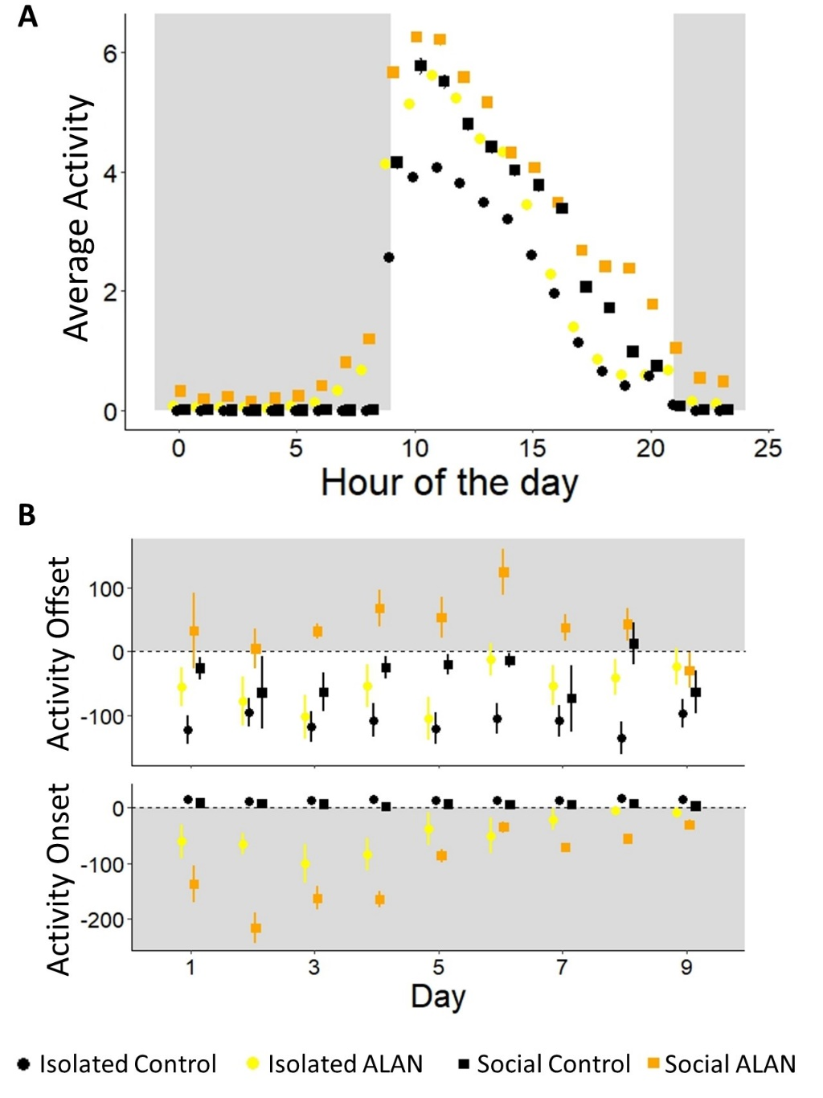

**Figure 1. Activity cycles for birds exposed to dim ALAN across social conditions.** (A) The mean daily activity profile over nine days, comparing ALAN-exposed birds to controls under dark night conditions. (B) Comparisons of activity onset and offset times between isolated and social conditions under ALAN exposure and control settings. For activity onset, 0 represents light on and numerical values represent time in minutes of activity onset relative to lights on. For activity offset, 0 represents lights off and numerical values represent time in minutes of activity offset relative to lights off. Gray areas indicate day lights off. Data are reported as mean ± SE.

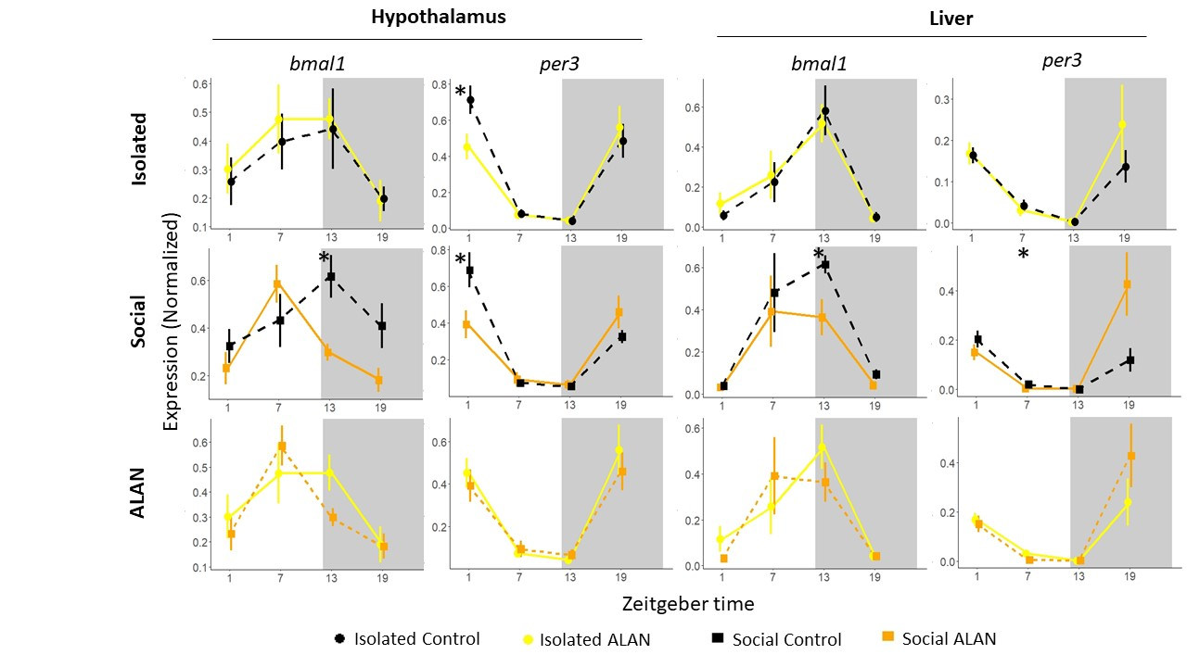

**Figure 2. Daily circadian gene expression in the hypothalamus and liver under ALAN.** Normalized expression of *bmal1* and *per3* collected at four time points throughout the day. Shaded portions represent nighttime (ZT 12-ZT 24). Birds exposed to ALAN were significantly different from controls in *per3* expression at ZT 1 (Isolated: p = 0.03, Social: p = 0.04) and only social ALAN birds were significantly different from social controls in *bmal1* expression at ZT 13 (p = 0.01) in the hypothalamus. Birds exposed to ALAN in social conditions were significantly different from social controls in *bmal1* expression at ZT 13 (p = 0.03) and *per3* expression at ZT 7 (p = 0.05) in the liver. Asterisks: ‘*’ p < 0.05, ‘**’ p < 0.01, ‘***’ p < 0.001.

*ALAN Alters Gene Expression, Especially in Social Birds*

To determine activity onset origin, we analyzed core circadian genes in the hypothalamus and peripheral genes in the liver. We observed consistent daily rhythms in the expression of circadian genes *cry1, per2,* and *per3* within the hypothalamus across all treatments (all p-values < 0.01: Figure 2; Figure S1). In contrast, *bmal1* expression exhibited less pronounced rhythmicity, with variability observed across different conditions (Isolated control: p = 0.08, Isolated ALAN: p = 0.01, Social control: p = 0.03, Social ALAN: p < 0.01). No significant differences were found in the phase or amplitude of *cry1, per2,* and *per3* expressions between control and ALAN-exposed groups (Table S2). We identified a significant phase shift in *bmal1* expression among social ALAN birds compared to their social controls (p < 0.01) and not in isolated conditions (p = 0.77). *bmal1* expression significantly decreased among socially housed birds under ALAN at ZT 13 (t = -3.30, p = 0.01; Figure 2) that again was not seen in isolated birds (t = 0.22, p = 0.83). However, regardless of social condition, *per3* expression significantly decreased in birds exposed to ALAN relative to their respective controls at ZT 1 (Isolated: t = -2.48, p = 0.03, Social: t = -2.42, p = 0.04).

Robust daily oscillations were also found in *bmal1, cry1, per2,* and *per3* expression in the livers, consistent across all treatments (all p-values < 0.01). Comparisons of phase and amplitude between control groups and those exposed to ALAN showed no significant differences for *bmal1, cry1,* and *per2* expressions. However, the amplitude of *per3* expression increased in socially housed birds exposed to ALAN (p = 0.05), but not isolated birds (p = 0.26). Differences in individual timepoints were insignificant between isolated birds exposed to ALAN and controls. However, ALAN exposure significantly decreased *bmal1* expression at ZT 13 (t = -2.60, p = 0.03) and *per3* at ZT 7 (t = -2.68, p = 0.05) in socially housed birds.

We conducted a correlation matrix analysis at ZT 1 and 13 (closet to activity onset and offset) to examine the organization between gene expression levels in the hypothalamus and liver among birds subjected to ALAN exposure. There is a reorganization of the correlation between the hypothalamus and liver between isolated and social birds exposed to ALAN. In the early night (ZT 13), we see a stronger desynchronization of hypothalamic and liver gene expression in the socially housed birds (Figure 3A).

Additionally, we found that hypothalamic circadian genes (*bmal1, cry1,* and *per2*) expressed early in the morning (ZT 1) strongly predict (Figure 3B; all p < 0.01) activity onset of the last experimental day under ALAN. Control birds maintained an onset close to time 0, so it was unnecessary to include them in the analyses.

**Figure 3. Correlation matrix of circadian genes expressed in the hypothalamus and liver under ALAN and prediction of activity onset.** (A) Matrixes are separated by isolated or socially housed birds and time (early morning is ZT 1 and early night is 13). Dark blue shows a strong positive correlation and dark red shows a strong negative correlation between four circadian genes (*bmal1, cry1, per2,* and *per3*) in the hypothalamus and liver. (B) Circadian genes *bmal1* (p < 0.01), c*ry1* (p < 0.01), and p*er2* (p < 0.01) expressed in the hypothalamus at ZT 1 predict activity onset of the last experimental day in birds exposed to ALAN. Lines are fitted with statistically significant linear regression models and shaded portions represent 95% confidence interval. Points represent individuals.

*Melatonin in Unaffected by ALAN*

We measured melatonin levels to determine if the altered circadian genes were disrupting downstream physiological rhythms. Melatonin concentrations oscillated throughout the day in all groups. The amplitude (Isolated: z = 0.12, p = 0.73; Social: z = 0.04, p = 0.84) and phase (Isolated: z = 0.06, p = 0.81; Social: z = 0.16, p = 0.69) of melatonin did not differ between birds exposed to ALAN and controls regardless of social condition (Figure S2).

**Discussion**

We show that central and peripheral circadian gene expression was exacerbated when birds were housed together, leading to increased desynchronization of correlated brain and liver expression. Advanced activity onset was also strongly correlated to gene expression in the hypothalamus but did not affect downstream melatonin expression. We highlight that social context strongly affects gene expression and circadian misalignment, exacerbating responses to external stressors.

We found ALAN exposure increased nocturnal activity and caused earlier activity onset, which was intensified by social interactions. Furthermore, ALAN exposure decreased *per3* expression in the hypothalamus uniformly, but *bmal1* expression was only disrupted in social birds in central (hypothalamus) and peripheral (liver) clocks. The interaction of ALAN’s effects across social conditions was supported by the relationship of circadian hypothalamic genes on activity onset. It has been debated in the field as to whether these two are connected, with some studies showing molecular and behavioral changes (*21, 22*) while others show behavioral changes in the absence of underlying circadian molecular changes (*7, 23*). Previous research linked *bmal1* gene expression with activity onset (*21*). We found hypothalamic expression, in the early morning, of *bmal1*, *cry1*, and *per2* significantly predicted activity onset, supporting Dominoni et al’s finding while linking two more circadian genes to activity onset. In social groups, these genes' expression was more severely affected by ALAN, correlating with stronger advances in activity onset.

The central clock in the SCN performs the crucial role of synchronizing peripheral clocks across an organism, with desynchronization leading to health deficits (*24, 25*). ALAN, and other stressors, have the capability of disrupting peripheral rhythms even if behavioral rhythms or the core clock are untouched, desynchronizing the organism’s system (*26, 27*). We found that ALAN reorganized the relationship of circadian genes differently in birds that were isolated compared to grouped. Different patterns emerged between the two treatments and in the early night we saw increased desynchronization of central and peripheral clocks particularly for social birds. Therefore, in social settings, ALAN not only disrupts both core and peripheral clocks but also leads to a greater degree of desynchronization in their relationship compared to isolated birds.

Contrary to our hypothesis, we observed no significant differences in melatonin levels across treatment groups, suggesting that the mechanism by which ALAN and social interactions affect circadian rhythms may not directly involve melatonin suppression. There are mixed findings on ALAN’s ability to suppress melatonin (*6-8, 28*). Some prior studies reported ALAN-induced melatonin disruption in birds, housed individually or socially (*6, 28, 29*). However, we previously found no suppression of melatonin in bird housed individually (*7*) and another study in humans found negative effects from ALAN independent of melatonin excretion (*8*). These discrepancies may be due to species, light intensity, and individual variation, demonstrating the complex interplay of physiological responses to environmental change.

The synchronization of circadian rhythms, facilitated by social cues, is a critical aspect of social coordination. However, within flies, an individual with a disrupted timing can propagate this disruption throughout an entire group, allowing them to adopt the altered rhythm (*17*). This mechanism may explain why in our study social birds under ALAN showed greater disruption in circadian gene expression, desynchronization, and activity patterns compared to their isolated counterparts. The specific mechanism of social information propagation or disturbance, e.g., visual, acoustic, etc., is worth of future investigation (*13, 30-32*). We speculate that individuals within a social group who are particularly sensitive to ALAN might influence the circadian rhythm of the entire group.

Our data are the first of our knowledge to demonstrate a molecular shift in circadian regulation due to social interactions in vertebrates. This study emphasizes the role of social context in understanding the effects of environmental disturbances like ALAN. The exacerbated responses observed in social settings suggest that collective behaviors might amplify responses to light pollution. This finding has significant implications for understanding the ecological impacts of ALAN, as social dynamics and group living are common across many taxa. Furthermore, these findings highlight the importance of incorporating social contexts into research designs to obtain more relevant insights into the biological impacts of environmental stressors.

Our investigation into the effects of ALAN on zebra finches reveals that social interactions significantly amplify circadian disruptions. These findings contribute to a growing body of evidence indicating the profound impact of light pollution on biological rhythms and highlight the need for further research into mitigating these effects. Future studies should explore the underlying mechanisms of social amplification of ALAN effects and assess the ecological consequences of disrupted circadian rhythms in group-living species. The findings of this study shed light on the complex interplay between social conditions in response to ALAN exposure and the importance of accounting for social context in experimental lab settings as results may otherwise be less applicable to natural life.

**Acknowledgments**

JQO is funded by NSF IOS-2141693. We thank Shawheen Bayani,

Ryan Phan, and Grace Aspden for logistical support. SB and RP received funding from Nevada INBRE Undergraduate Research Opportunity Program. Research reported in this publication used the Cellular and Molecular Imaging Core facility supported by the National Institute of General Medical Sciences of the National Institutes of Health under grant number P20 GM103650.

**References**

1. D. M. Dominoni, R. J. Nelson, Artificial light at night as an environmental pollutant: An integrative approach across taxa, biological functions, and scientific disciplines. *Journal of Experimental Zoology Part a-Ecological and Integrative Physiology* **329**, 387-393 (2018).

2. J. C. Dunlap, Molecular bases for circadian clocks. *Cell* **96**, 271-290 (1999).

3. V. M. Cassone, Avian circadian organization: A chorus of clocks. *Frontiers in Neuroendocrinology* **35**, 76-88 (2014).

4. N. Murakami, T. Kawano, K. Nakahara, T. Nasu, K. Shiota, Effect of melatonin on circadian rhythm, locomotor activity and body temperature in the intact house sparrow, Japanese quail and owl. *Brain Research* **889**, 220-224 (2001).

5. Y. Touitou, A. Reinberg, D. Touitou, Association between light at night, melatonin secretion, sleep deprivation, and the internal clock: Health impacts and mechanisms of circadian disruption. *Life Sciences* **173**, 94-106 (2017).

6. S. Moaraf *et al.*, Artificial light at night affects brain plasticity and melatonin in birds. *Neuroscience Letters* **716**, (2020).

7. V. J. Alaasam *et al.*, Effects of dim artificial light at night on locomotor activity, cardiovascular physiology, and circadian clock genes in a diurnal songbird. *Environmental Pollution* **282**, (2021).

8. K. Obayashi, K. Saeki, J. Iwamoto, Y. Ikada, N. Kurumatani, Association between light exposure at night and nighttime blood pressure in the elderly independent of nocturnal urinary melatonin excretion. *Chronobiology International* **31**, 779-786 (2014).

9. C. K. Hui *et al.*, Dim artificial light at night alters immediate early gene expression throughout the avian brain. *Frontiers in Neuroscience* **17**, (2023).

10. J. Q. Ouyang, S. Davies, D. Dominoni, Hormonally mediated effects of artificial light at night on behavior and fitness: linking endocrine mechanisms with function. *Journal of Experimental Biology* **221**, (2018).

11. O. Siehler, S. Wang, G. Bloch, Social synchronization of circadian rhythms with a focus on honeybees. *Philosophical Transactions of the Royal Society B-Biological Sciences* **376**, (2021).

12. G. Marimuthu, S. Rajan, M. K. Chandrashekaran, SOCIAL ENTRAINMENT OF THE CIRCADIAN-RHYTHM IN THE FLIGHT ACTIVITY OF THE MICROCHIROPTERAN BAT HIPPOSIDEROS-SPEORIS. *Behavioral Ecology and Sociobiology* **8**, 147-150 (1981).

13. A. Rath, M. Benita, J. Doron, I. Scharf, D. Gottlieb, Social communication activates the circadian gene Tctimeless in Tribolium castaneum. *Scientific Reports* **11**, (2021).

14. N. Goel, T. M. Lee, Social cues accelerate reentrainment of circadian rhythms in diurnal female Octodon degus (Rodentia-Octodontidae). *Chronobiology International* **12**, 311-323 (1995).

15. K. P. Maruska, R. D. Fernald, Social Regulation of Gene Expression in the Hypothalamic-Pituitary-Gonadal Axis. *Physiology* **26**, 412-423 (2011).

16. K. Chaturvedi, A. Srivastava, S. Malik, S. Rani, The presence/absence of conspecifics modulates the circadian locomotor activity and body mass in spotted munia (<i>Lonchura punctulata</i>). *Chronobiology International* **41**, 105-126 (2024).

17. J. D. Levine, P. Funes, H. B. Dowse, J. C. Hall, Resetting the circadian clock by social experience in Drosophila melanogaster. *Science* **298**, 2010-2012 (2002).

18. N. Goel, T. M. Lee, Olfactory bulbectomy impedes social but not photic reentrainment of circadian rhythms in female Octodon degus. *Journal of Biological Rhythms* **12**, 362-370 (1997).

19. N. A. Jha, V. Kumar, Female conspecifics restore rhythmic singing behaviour in arrhythmic male zebra finches. *Journal of Biosciences* **42**, 139-147 (2017).

20. V. J. Alaasam *et al.*, Light at night disrupts nocturnal rest and elevates glucocorticoids at cool color temperatures. *Journal of Experimental Zoology Part a-Ecological and Integrative Physiology* **329**, 465-472 (2018).

21. D. M. Dominoni *et al.*, Artificial light at night leads to circadian disruption in a songbird: integrated evidence from behavioural, genomic and metabolomic data. *bioRxiv*, 2020.2012.2018.423473 (2021).

22. L. K. Fonken, R. J. Nelson, The Effects of Light at Night on Circadian Clocks and Metabolism. *Endocrine Reviews* **35**, 648-670 (2014).

23. K. Spoelstra, I. Verhagen, D. Meijer, M. E. Visser, Artificial light at night shifts daily activity patterns but not the internal clock in the great tit (Parus major). *Proceedings of the Royal Society B-Biological Sciences* **285**, (2018).

24. A. Patke, M. W. Young, S. Axelrod, Molecular mechanisms and physiological importance of circadian rhythms. *Nature Reviews Molecular Cell Biology* **21**, 67-84 (2020).

25. F. Catalano *et al.*, Circadian Clock Desynchronization and Insulin Resistance. *International Journal of Environmental Research and Public Health* **20**, (2023).

26. Y. Tahara *et al.*, Entrainment of the mouse circadian clock by sub-acute physical and psychological stress. *Scientific Reports* **5**, (2015).

27. J. C. Borniger, S. K. Maurya, M. Periasamy, R. J. Nelson, Acute dim light at night increases body mass, alters metabolism, and shifts core body temperature circadian rhythms. *Chronobiology International* **31**, 917-925 (2014).

28. I. Mishra *et al.*, Light at night disrupts diel patterns of cytokine gene expression and endocrine profiles in zebra finch (Taeniopygia guttata). *Scientific Reports* **9**, (2019).

29. D. M. Dominoni, W. Goymann, B. Helm, J. Partecke, Urban-like night illumination reduces melatonin release in European blackbirds (<i>Turdus merula</i>): implications of city life for biological time-keeping of songbirds. *Frontiers in Zoology* **10**, (2013).

30. M. J. Paul, P. Indic, W. J. Schwartz, Social forces can impact the circadian clocks of cohabiting hamsters. *Proceedings of the Royal Society B-Biological Sciences* **281**, (2014).

31. F. B. Goncalves, B. S. B. Goncalves, J. S. Cavalcante, C. V. M. Azevedo, Aging-related changes on social synchronization of circadian activity rhythm in a diurnal primate (Callithrix jacchus). *Chronobiology International* **37**, 980-992 (2020).

32. Y. Ping, L. Z. Shao, M. Z. Li, L. N. Yang, J. X. Zhang, Contribution of Social Influences through Superposition of Visual and Olfactory Inputs to Circadian Re-entrainment. *Iscience* **23**, (2020).